**WELBECK ROAD HEALTH CENTRE**

**Breastfeeding Welcome Here Space**

**Policy**

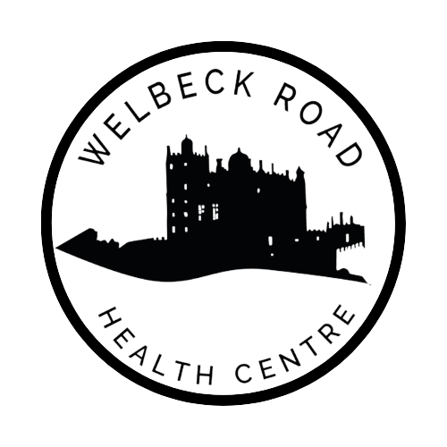

|  |  |
| --- | --- |
| **Authorised by:** | **PARTNERS** |
| **Document Author:** | **Sarah Fillipich** |
| **Last review:** | **January 2025** |
| **Due for review:** | **January 2026** |

**‘Breastfeeding Welcome Here Award’**

As we have taken the decision to support our local community by signing up to be a registered 'Safe Place', we thought that the Derbyshire County Council “**Breastfeeding Welcome Here Award**”, may also be of interest to our patients.

We are aware that breastfeeding has lots of positive impacts on the health of mums and their infants, and so we’re passionate about supporting Bolsover families. An important part of this is making sure that families feel comfortable to feed whilst out and about.

As a venue who makes their premises welcoming for breastfeeding families, we can positively impact on the health of these families. Having a breastfeeding friendly venue can help families to feel confident to breastfeed in public.

As a result of this, Derbyshire County Council run the 'Breastfeeding Welcome Here Award' of which we are involved in. It is a free accreditation scheme to show that we support families to breastfeed.

***The aims of the Breastfeeding Welcome Here Award are to:***

* Help community venues show they actively welcome and support breastfeeding.
* Support new families to feel confident breastfeeding when out and about.
* Improve awareness about the lifelong benefits of breastfeeding for mother and child.
* Remove any barriers that may prevent people from breastfeeding in public.

***The benefits for a venue signing up are:***

* The scheme is free to join.
* It provides free, positive, publicity.
* GP and dental practices can improve patient satisfaction and patient health.
* By supporting breastfeeding, venues will be making a positive contribution to the health of families across Derbyshire.

***This means that Welbeck Road Health Centre:***

* Welcome mums to breastfeed their babies on our premises.
* We would never ask a mum to move or leave because she is breastfeeding her baby.
* Do our best to offer a private area for mothers to feed in, if space allows.
* Make our staff aware that the practice supports the 'Breastfeeding Welcome Here Award' and encourages Mothers to breastfeed on the premises.
* Display the Breastfeeding Welcome Here certificate and stickers so that mums know that we are part of the scheme.

The scheme recommends that we, Welbeck Road Health Centre, ensure all staff are aware of the [Breastfeeding Equality Act 2010](https://maternityaction.org.uk/advice/breastfeeding-in-public-places/) and know how to deal with any comments from patients. The Breastfeeding Equality Act states that it is discrimination to treat a woman unfavourably because she is breastfeeding. It applies to anyone providing services, benefits, facilities and premises to the public, public bodies, further and higher education bodies and association. Service providers include most organisations that deal directly with the public. Service providers must not discriminate, harass or victimise a woman because she is breastfeeding.

More information can be found online here: [Equality Act 2010: guidance - GOV.UK](https://www.gov.uk/guidance/equality-act-2010-guidance)

Our practicewill beautomaticallyadvertised on our [health visiting service](https://gbr01.safelinks.protection.outlook.com/?url=https%3A%2F%2Fderbyshirefamilyhealthservice.nhs.uk%2Fbreastfeeding&data=05%7C02%7Cchrissie.connaughton%40nhs.net%7Cda6dd20a123f43c1149008dd405b657f%7C37c354b285b047f5b22207b48d774ee3%7C0%7C0%7C638737483460554058%7CUnknown%7CTWFpbGZsb3d8eyJFbXB0eU1hcGkiOnRydWUsIlYiOiIwLjAuMDAwMCIsIlAiOiJXaW4zMiIsIkFOIjoiTWFpbCIsIldUIjoyfQ%3D%3D%7C0%7C%7C%7C&sdata=QeL4H0hgbEr%2BCRqw75NQ2nwmL1UqPmB9%2BNNF4ByhIuk%3D&reserved=0) so families can see Breastfeeding Welcome Here venues in their area.

For any queries please contact the Start Well Team on email: [breastfeedingwelcomeaward@derbyshire.gov.uk](mailto:breastfeedingwelcomeaward@derbyshire.gov.uk)

Further information: <https://www.derbyshire.gov.uk/business/breastfeeding-welcome-here-award/the-breastfeeding-welcome-here-award.aspx>